Cloud Migration, Sales Curriculum

1. Cloud Migration, Sales Curriculum

1.1 Welcome

Notes:

1.2 Player Details
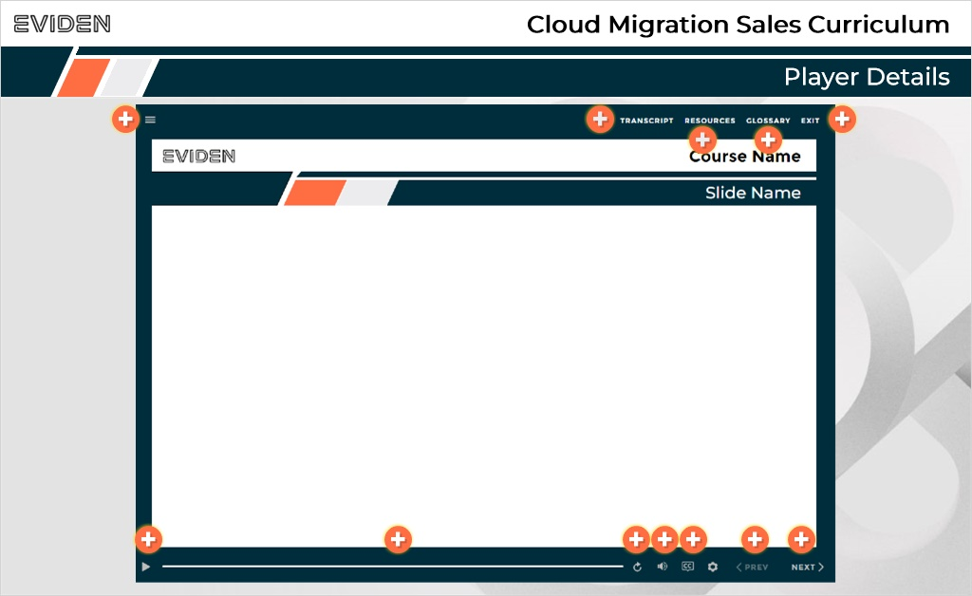
Notes:

1.3 Course Outline
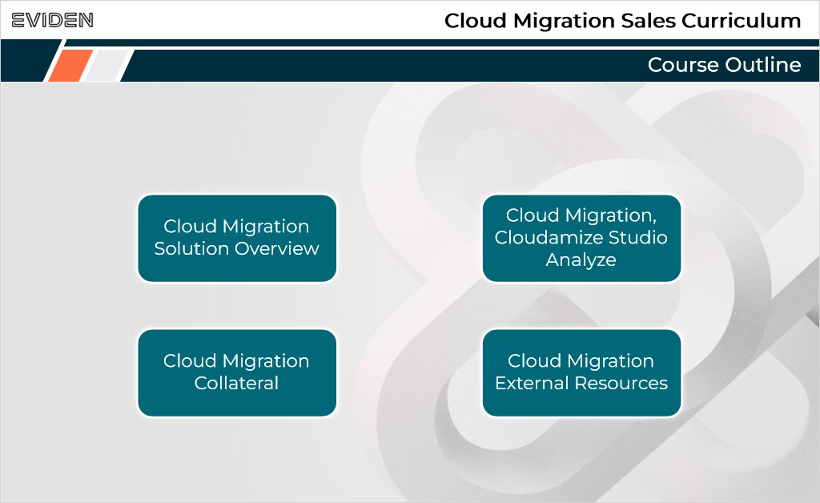
Notes:

1.4 Cloud Operations Interview Podcast
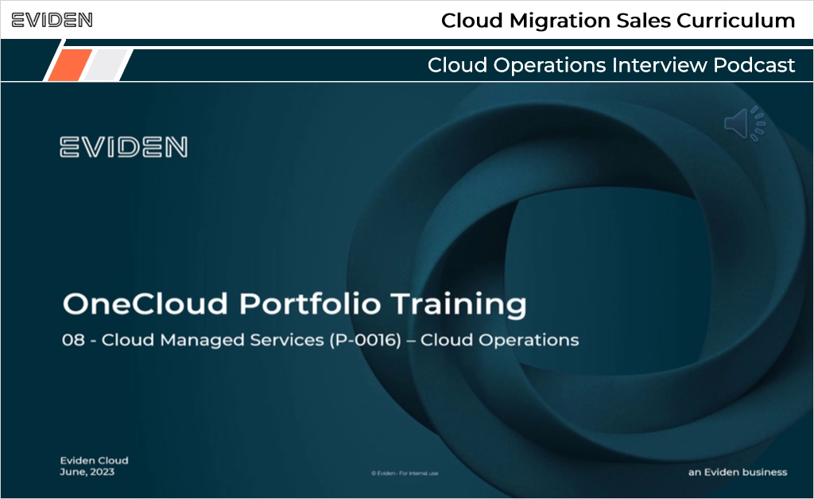
Notes:

1.5 Cloud Operations Overview Video
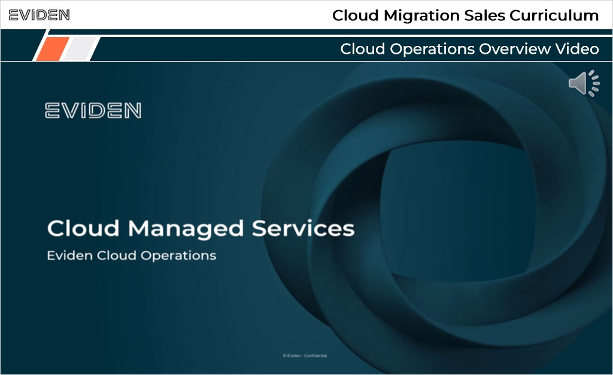

1.6 Cloud Operations Collateral
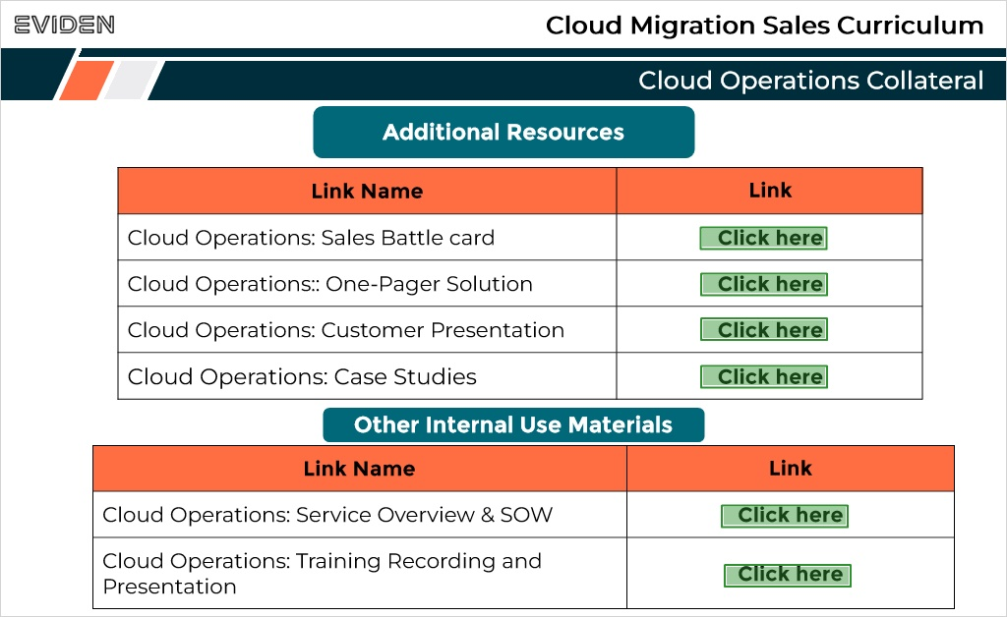
Notes:

2. Thank You

2.1 Thank You!

Notes:

3. Assessment

3.1 Assessment
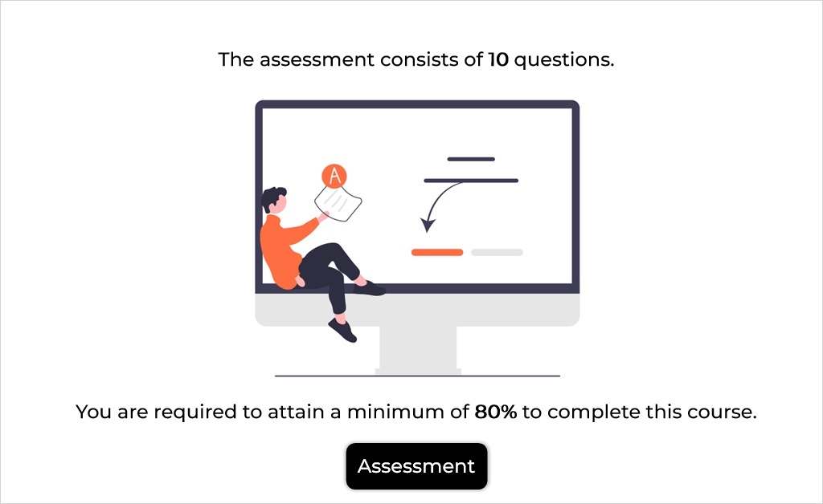
Notes:

3.2 Demo
Draw 10 questions randomly from Cloud Migration Sales Curriculum
Notes:

3.3 Results
(Results Slide, 0 points, 1 attempt permitted)
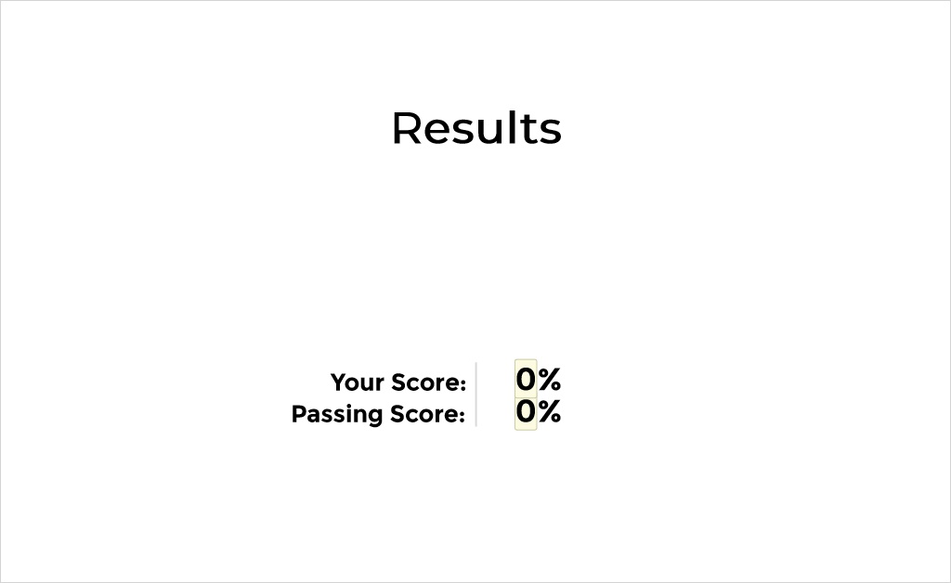

Results for
3.2 Demo

Result slide properties
Passing  Score | 80%

Notes:

Failure (Slide Layer)
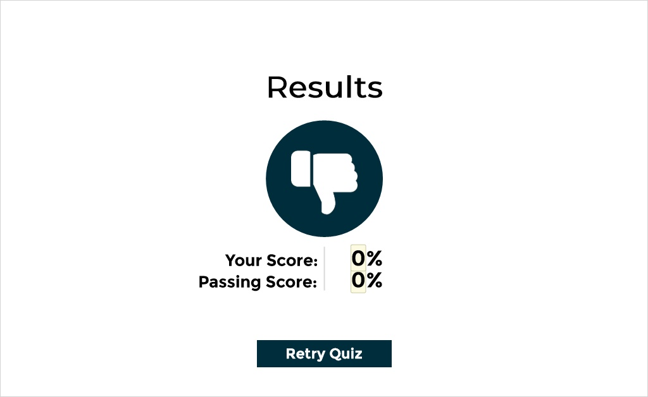

Success (Slide Layer)


1. Cloud Migration Sales Curriculum

Q1.1 Cloud Migration –Solution Overview Knowledge Check.
(Multiple Choice, 10 points, 1 attempt permitted)
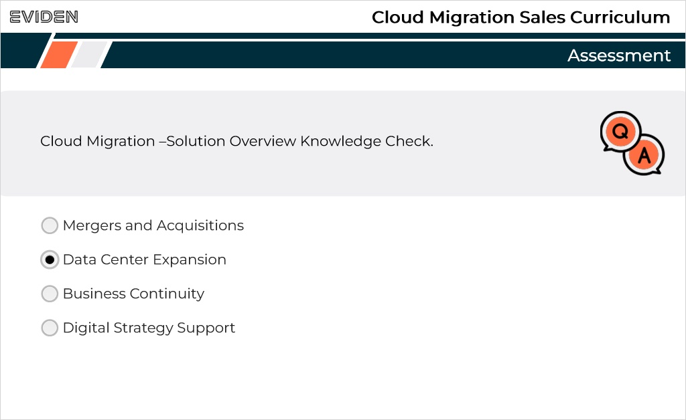
Correct | Choice
 | Mergers and Acquisitions
X | Data Center Expansion
 | Business Continuity
 | Digital Strategy Support

Feedback when correct:
That's right! You selected the correct response.
Feedback when incorrect:
You did not select the correct response.

Correct (Slide Layer)
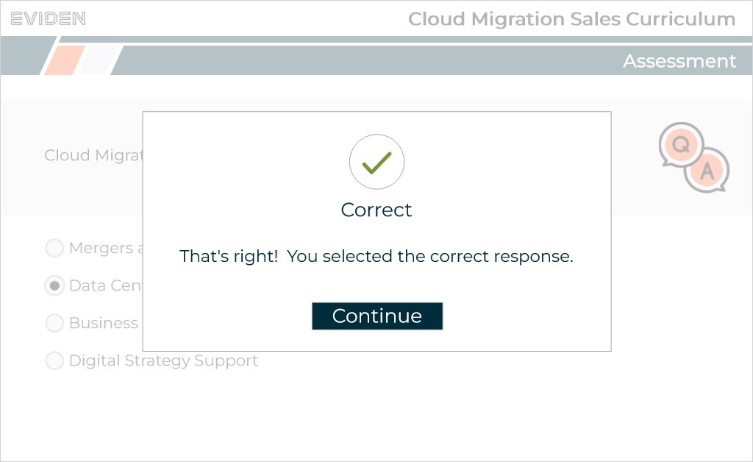

Incorrect (Slide Layer)
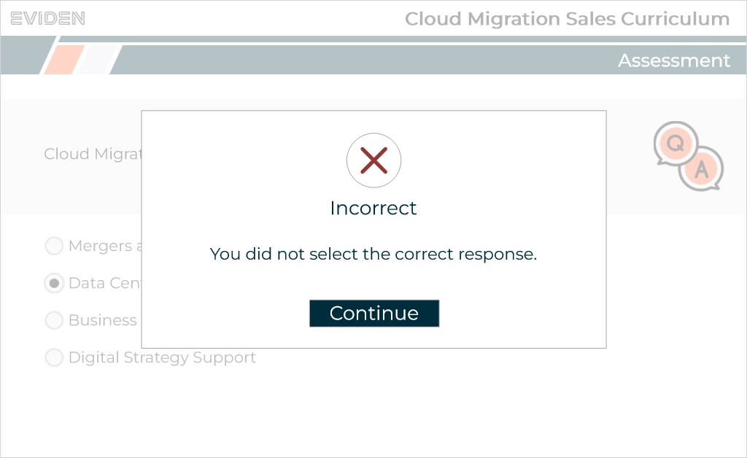

Q1.2 What are the three pillars of the migration solution mentioned in the video?
(Multiple Choice, 10 points, 1 attempt permitted)
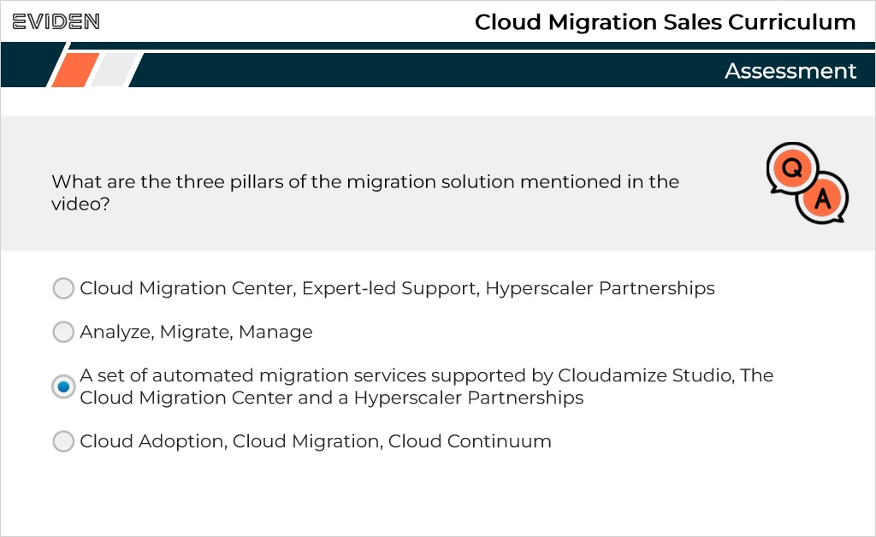
Correct | Choice
 | Cloud Migration Center, Expert-led Support, Hyperscaler Partnerships
 | Analyze, Migrate, Manage
X | A set of automated migration services supported by Cloudamize Studio, The Cloud Migration Center and a Hyperscaler Partnerships
 | Cloud Adoption, Cloud Migration, Cloud Continuum

Feedback when correct:
That's right! You selected the correct response.
Feedback when incorrect:
You did not select the correct response.

Correct (Slide Layer)
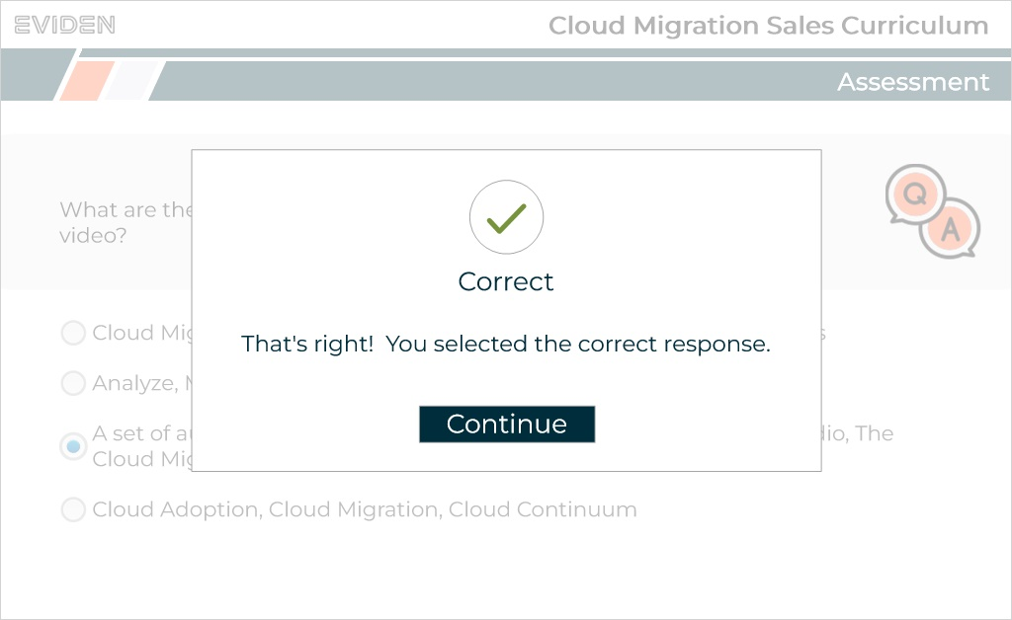

Incorrect (Slide Layer)
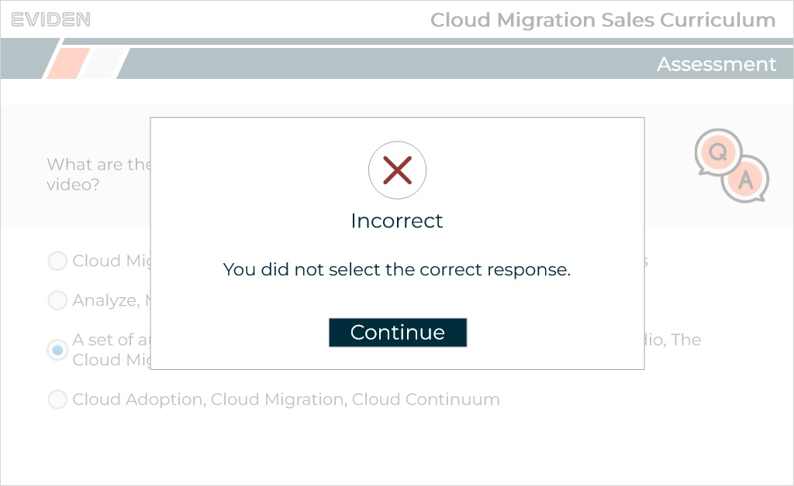

Q1.3 Which option below extends the services beyond the "Rapid Migration" offering to full-service support for live migrations across the Cloud Continuum?
(Multiple Choice, 10 points, 1 attempt permitted)
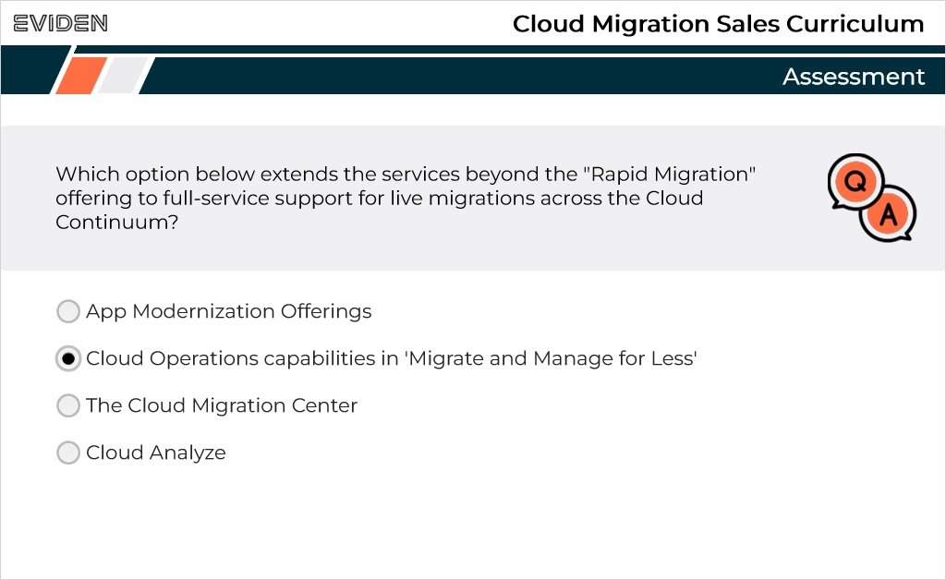
Correct | Choice
 | App Modernization Offerings
X | Cloud Operations capabilities in 'Migrate and Manage for Less'
 | The Cloud Migration Center
 | Cloud Analyze

Feedback when correct:
That's right! You selected the correct response.
Feedback when incorrect:
You did not select the correct response.

Correct (Slide Layer)
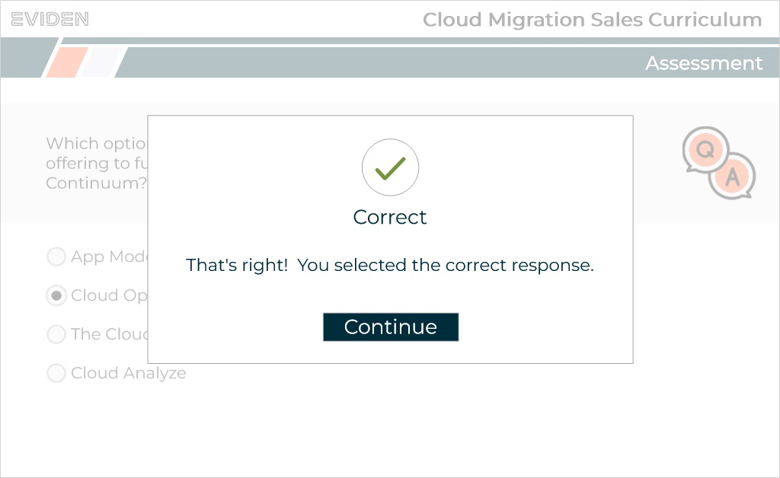

Incorrect (Slide Layer)
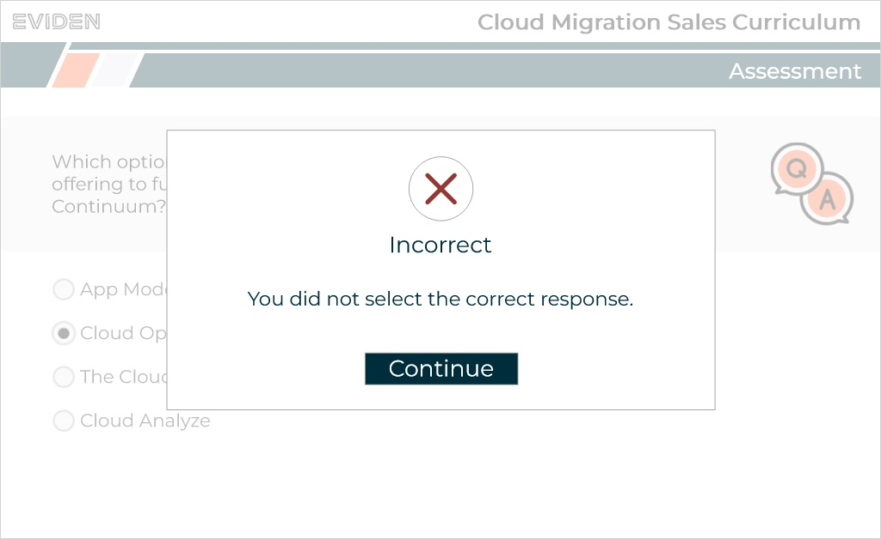

Q1.4 In which phase does the video mention capturing the current estate, mapping application dependencies, and ensuring customer readiness?
(Multiple Choice, 10 points, 1 attempt permitted)
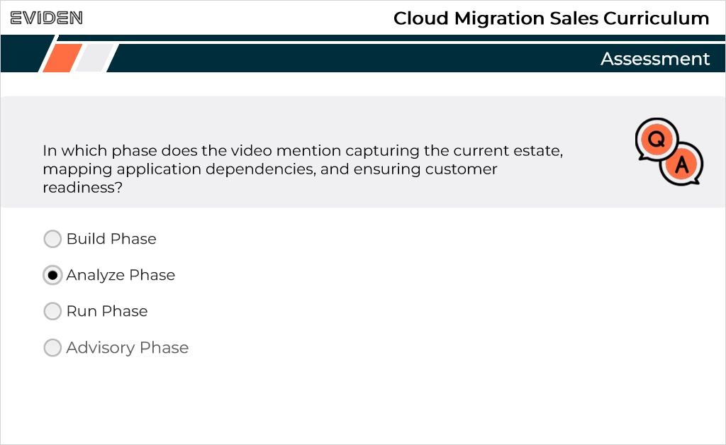
Correct | Choice
 | Build Phase
X | Analyze Phase
 | Run Phase
 | Advisory Phase

Feedback when correct:
That's right! You selected the correct response.
Feedback when incorrect:
You did not select the correct response.

Correct (Slide Layer)
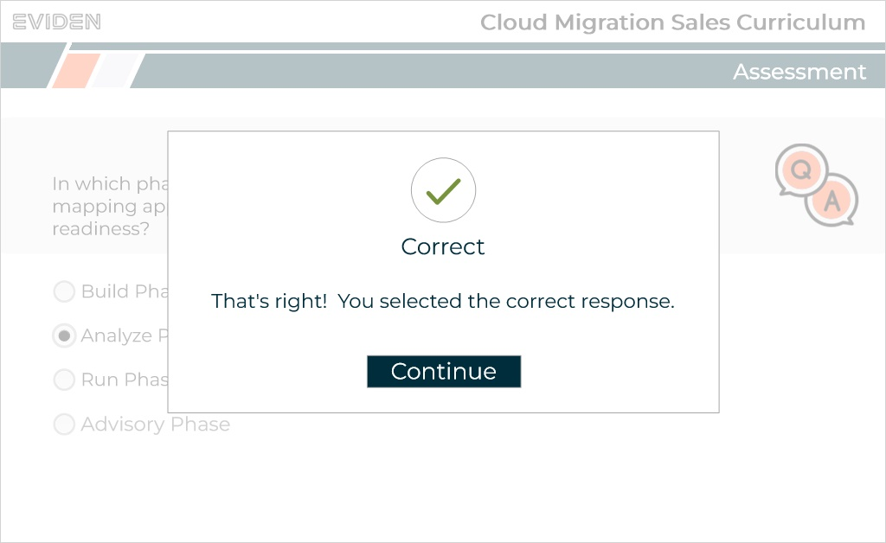

Incorrect (Slide Layer)
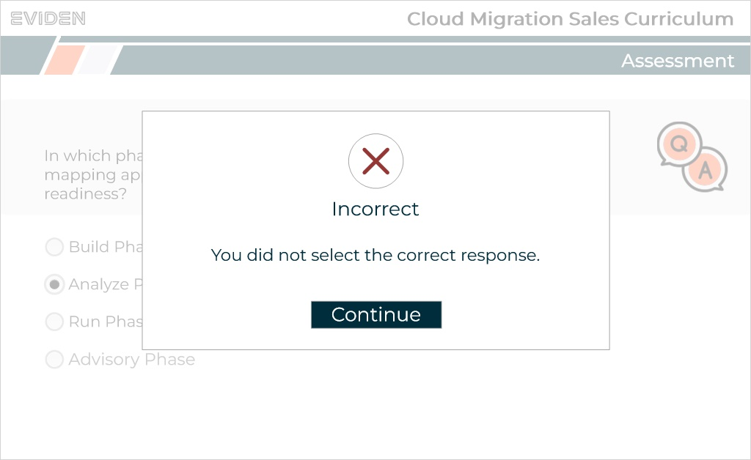

Q1.5 According to the video, what internal team should you involve early on in the process when considering hyperscaler options?
(Multiple Choice, 10 points, 1 attempt permitted)
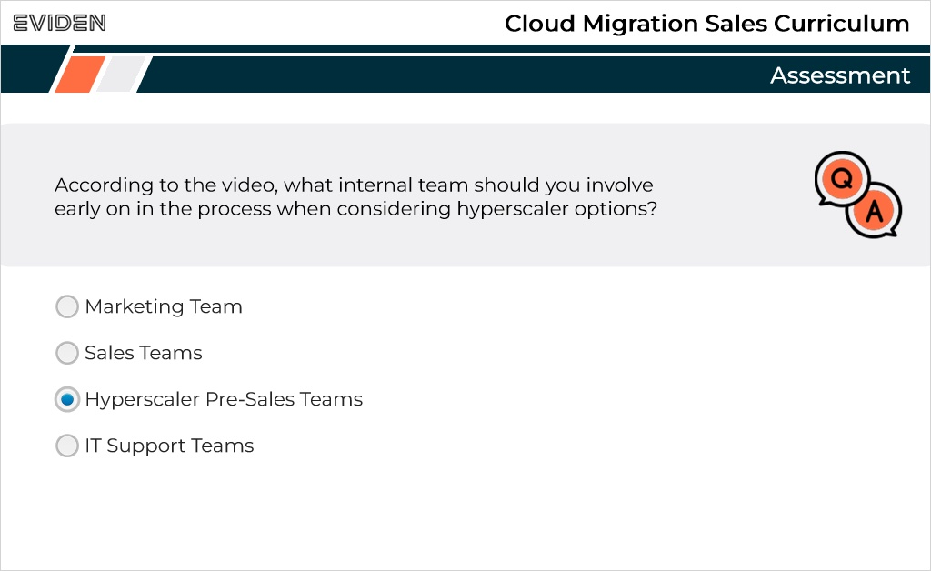
Correct | Choice
 | Marketing Team
 | Sales Teams
X | Hyperscaler Pre-Sales Teams
 | IT Support Teams

Feedback when correct:
That's right! You selected the correct response.
Feedback when incorrect:
You did not select the correct response.

Correct (Slide Layer)
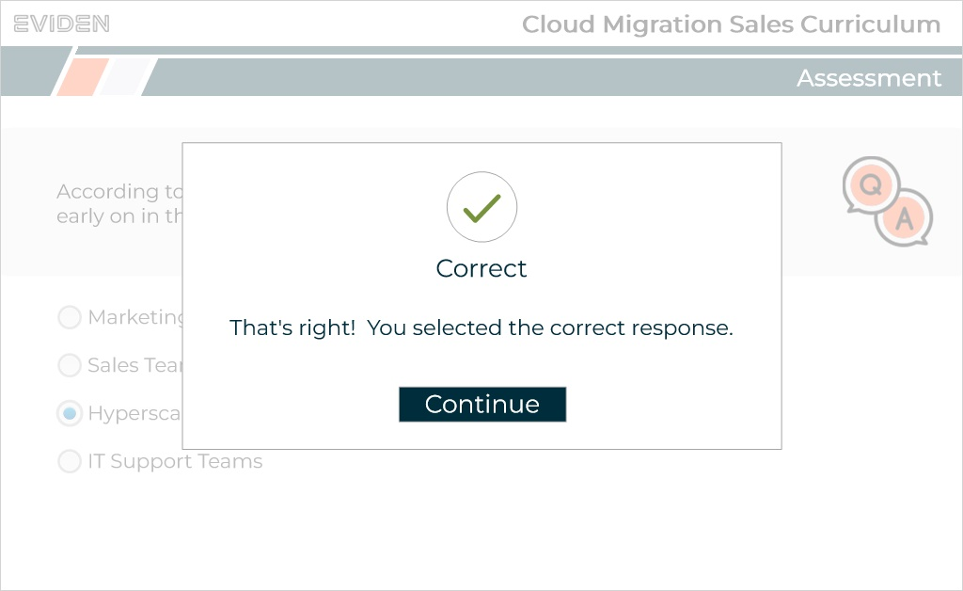

Incorrect (Slide Layer)
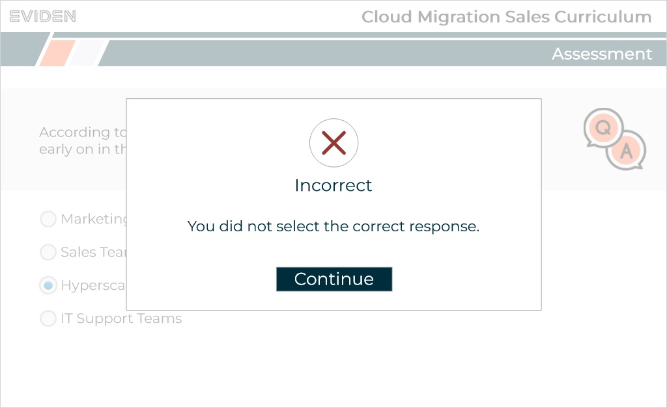

Q1.6 What should sales teams refer to for up-to-date price guidance and offerings?
(Multiple Choice, 10 points, 1 attempt permitted)
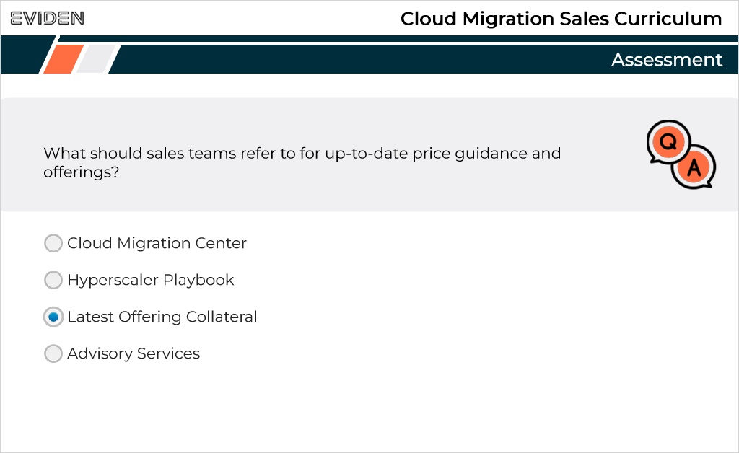
Correct | Choice
 | Cloud Migration Center
 | Hyperscaler Playbook
X | Latest Offering Collateral
 | Advisory Services

Feedback when correct:
That's right! You selected the correct response.
Feedback when incorrect:
You did not select the correct response.

Correct (Slide Layer)
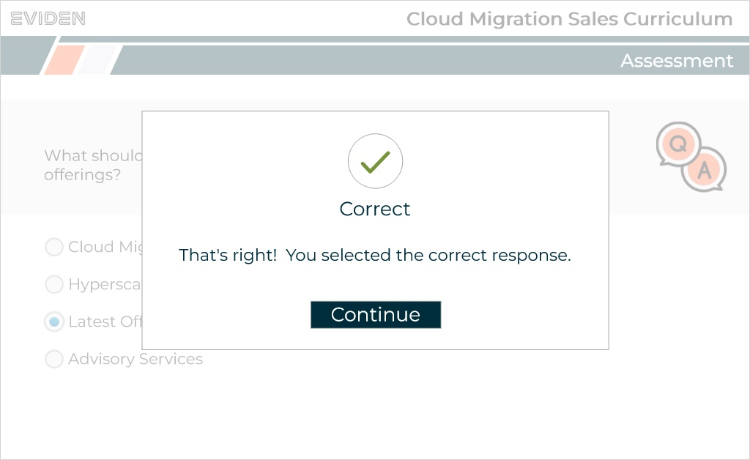

Incorrect (Slide Layer)
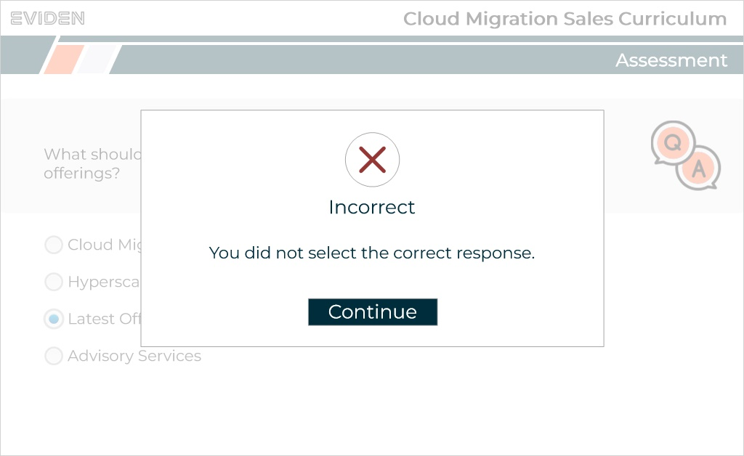

Q1.7 Why might a company consider migrating its IT and application service landscape to the cloud?
(Multiple Choice, 10 points, 1 attempt permitted)
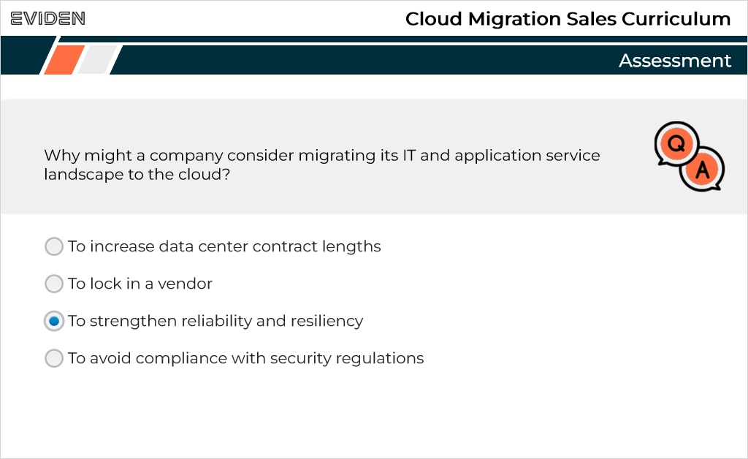
Correct | Choice
 | To increase data center contract lengths
 | To lock in a vendor
X | To strengthen reliability and resiliency
 | To avoid compliance with security regulations

Feedback when correct:
That's right! You selected the correct response.
Feedback when incorrect:
You did not select the correct response.

Correct (Slide Layer)
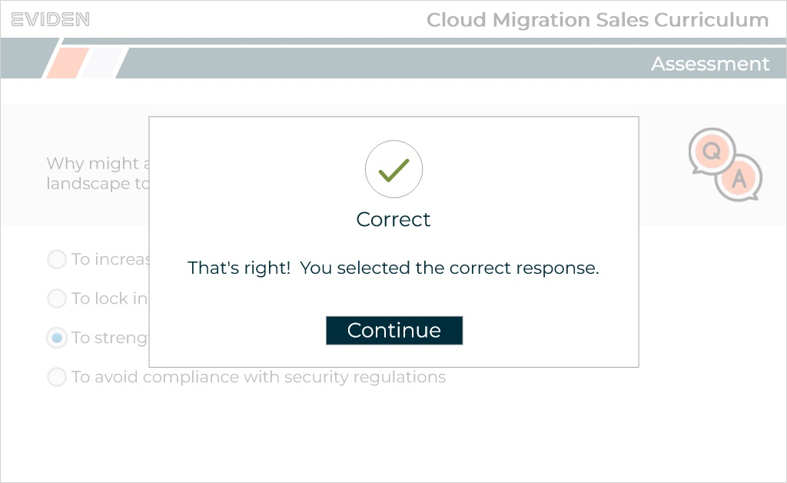

Incorrect (Slide Layer)
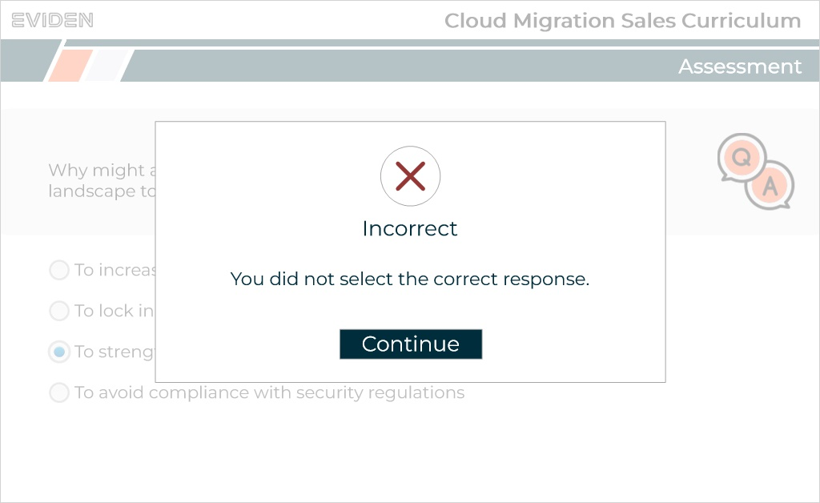

Q1.8 What are the locations we deliver CloudOps from called?
(Multiple Choice, 10 points, 1 attempt permitted)
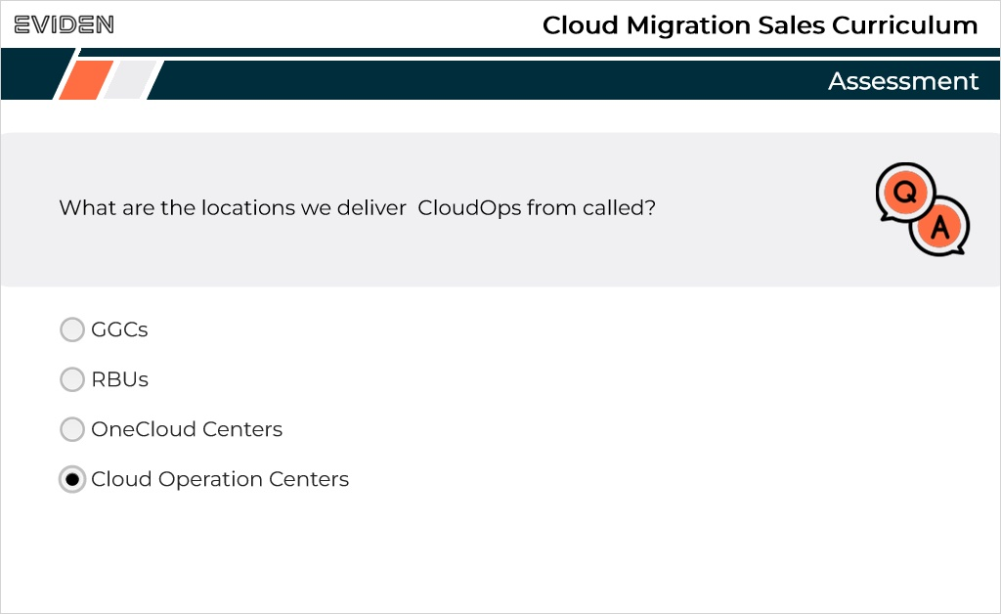
Correct | Choice
 | GGCs
 | RBUs
 | OneCloud Centers
X | Cloud Operation Centers

Feedback when correct:
That's right! You selected the correct response.
Feedback when incorrect:
You did not select the correct response.

Correct (Slide Layer)
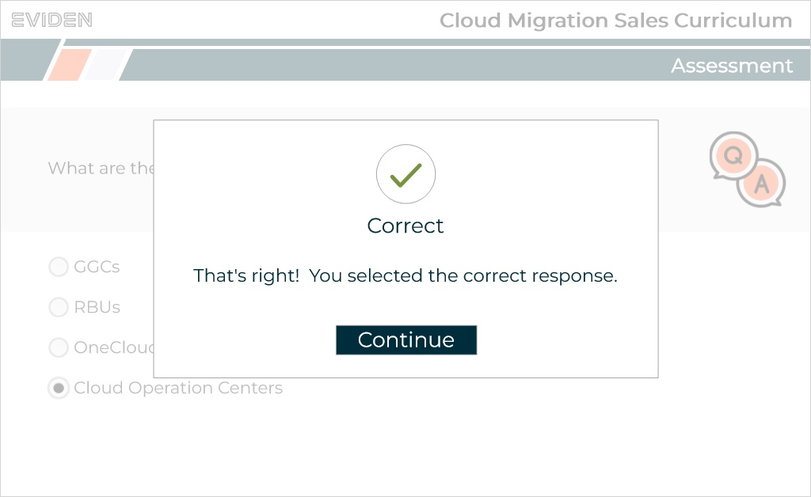

Incorrect (Slide Layer)
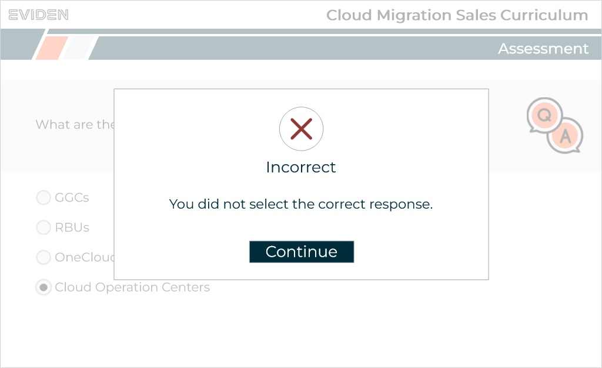

Q1.9 There are already s customers utilising Eviden CloudOps.
(Multiple Choice, 10 points, 1 attempt permitted)
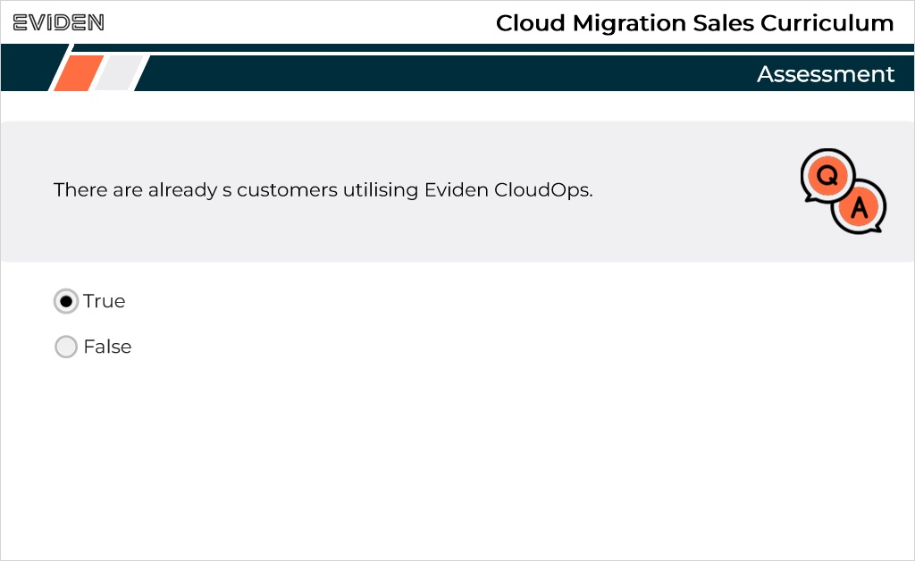
Correct | Choice
X | True
 | False

Feedback when correct:
That's right! You selected the correct response.
Feedback when incorrect:
You did not select the correct response.

Notes:

Correct (Slide Layer)
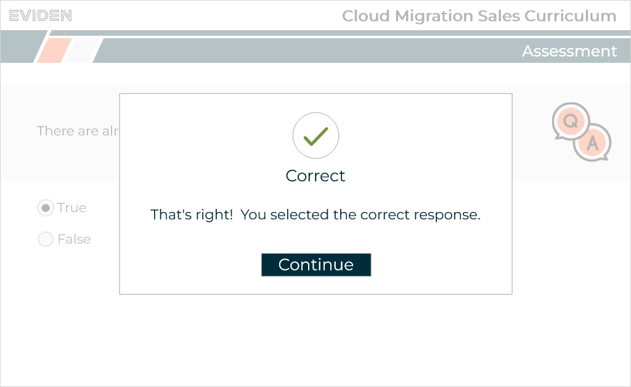

Incorrect (Slide Layer)
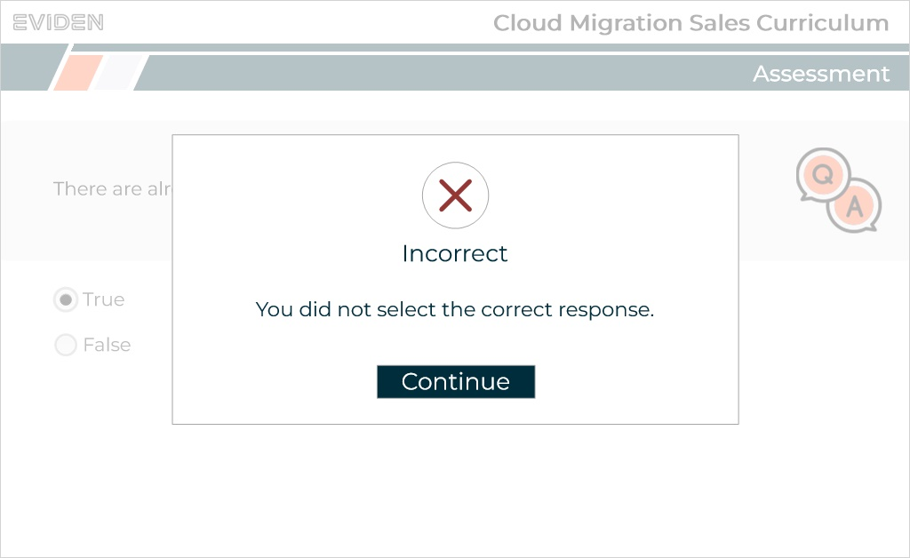

Q1.10 Among the following, what are the three tiers of services for CLoudOps?

Please select all that apply.
(Multiple Response, 10 points, 1 attempt permitted)
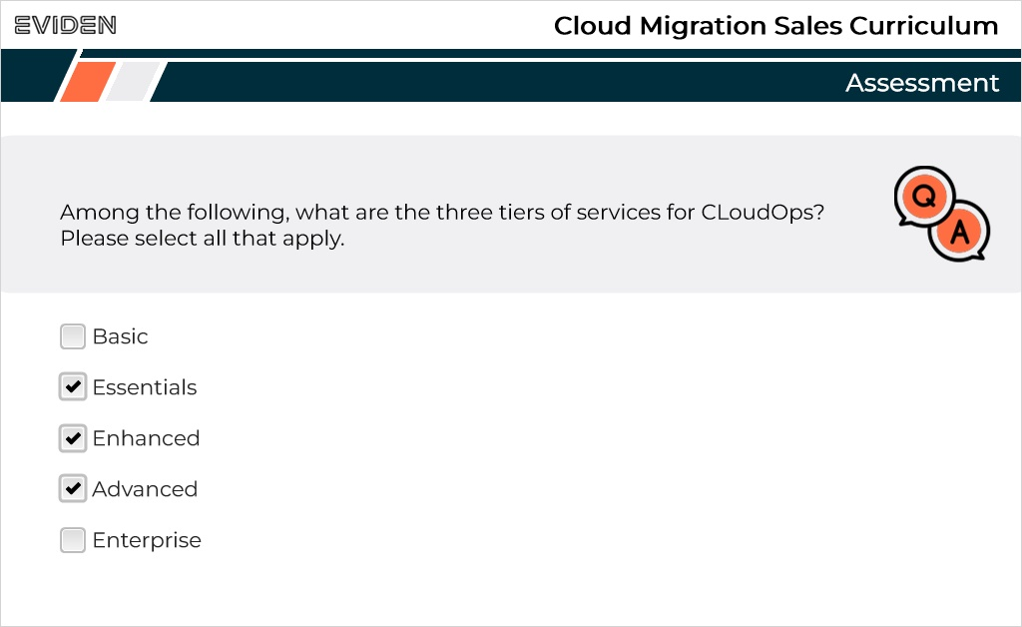
Correct | Choice
 | Basic
X | Essentials
X | Enhanced
X | Advanced
 | Enterprise

Feedback when correct:
That's right! You selected the correct response.
Feedback when incorrect:
You did not select the correct response.

Correct (Slide Layer)
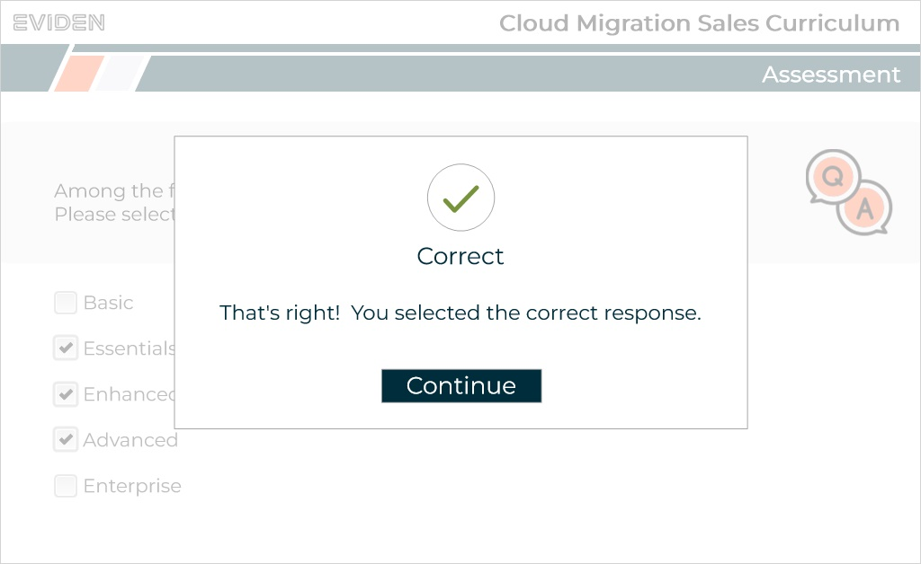

Incorrect (Slide Layer)
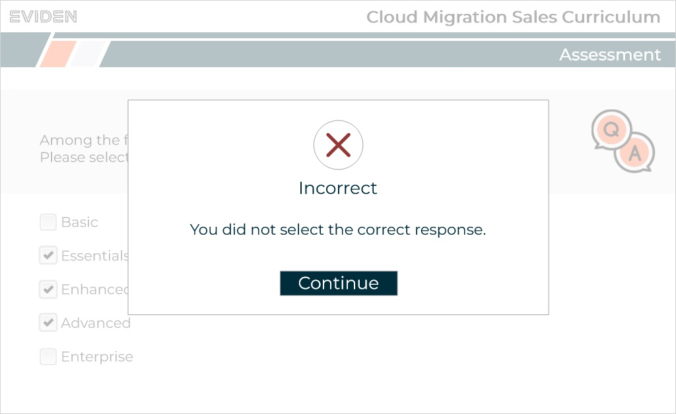

Q1.11 Select some of the CloudOps value for customers ?

Please select all that apply.
(Multiple Response, 10 points, 1 attempt permitted)
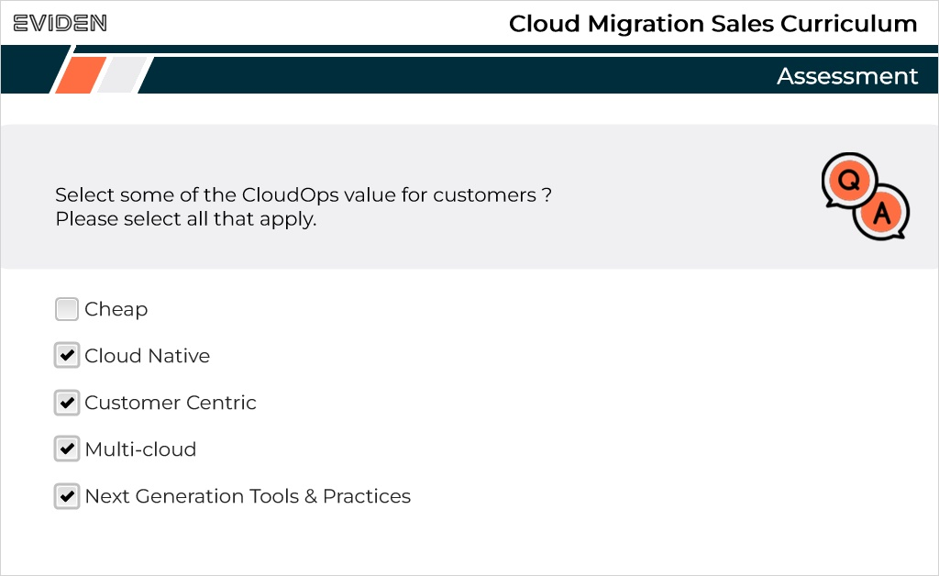
Correct | Choice
 | Cheap
X | Cloud Native
X | Customer Centric
X | Multi-cloud
X | Next Generation Tools & Practices

Feedback when correct:
That's right! You selected the correct response.
Feedback when incorrect:
You did not select the correct response.

Correct (Slide Layer)
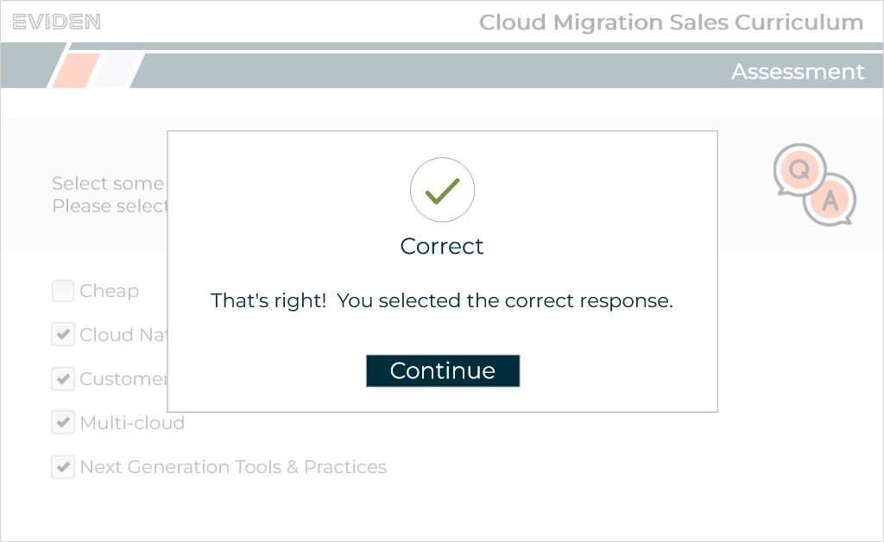

Incorrect (Slide Layer)
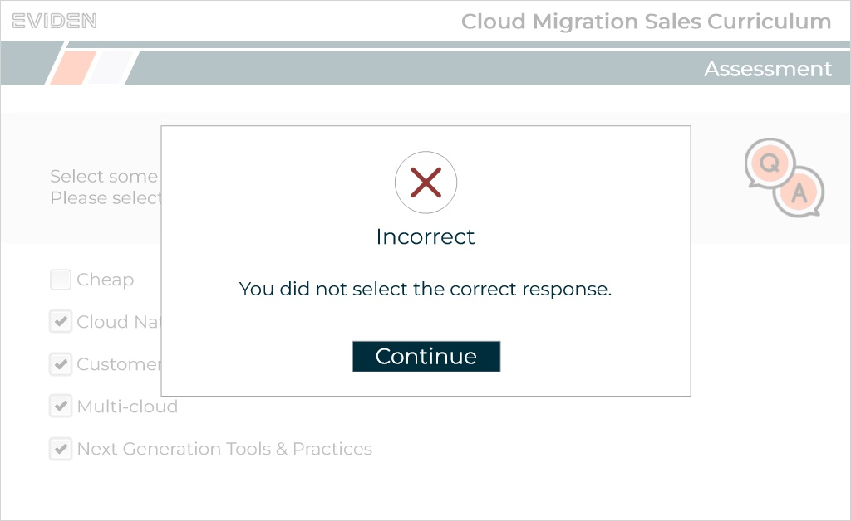

Q1.12 Which of the following are NOT core components of the CloudOps services?

Please select all that apply.
(Multiple Response, 10 points, 1 attempt permitted)
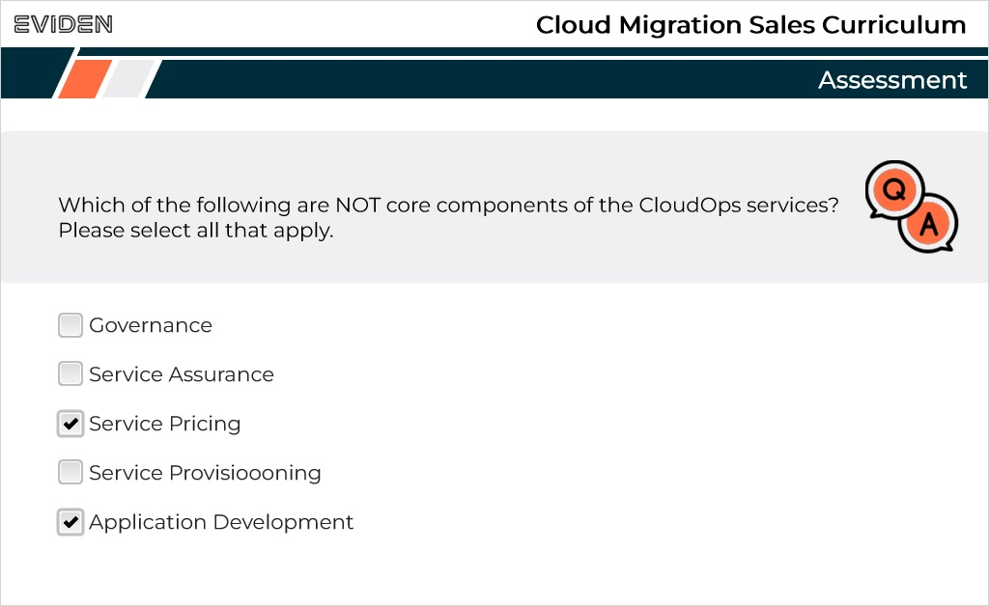
Correct | Choice
 | Governance
 | Service Assurance
X | Service Pricing
 | Service Provisioooning
X | Application Development

Feedback when correct:
That's right! You selected the correct response.
Feedback when incorrect:
You did not select the correct response.

Correct (Slide Layer)
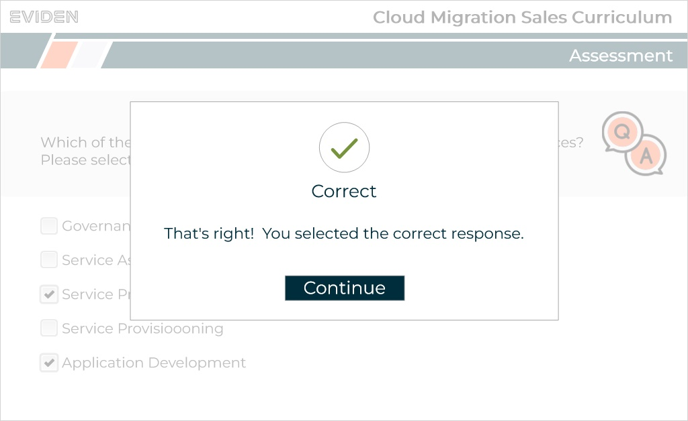

Incorrect (Slide Layer)
